

Republic of the Philippines

PROVINCE OF PAMPANGA

City of San Fernando, Pampanga

PHILIPPINE BIDDING DOCUMENTS

(As Harmonized with Development Partners)

**PROCUREMENT OF GOODS**

Government of the Republic of the Philippines

**PR No. 22 - 3719**

**Supply & Delivery of REAGENTS for MINDRAY BC-32, BC-3000 & BS-240**

Sixth Edition

July 2020

**Preface**

These Philippine Bidding Documents (PBDs) for the procurement of Goods through Competitive Bidding have been prepared by the Government of the Philippines for use by any branch, constitutional commission or office, agency, department, bureau, office, or instrumentality of the Government of the Philippines, National Government Agencies, including Government-Owned and/or Controlled Corporations, Government Financing Institutions, State Universities and Colleges, and Local Government Units. The procedures and practices presented in this document have been developed through broad experience, and are for mandatory use in projects that are financed in whole or in part by the Government of the Philippines or any foreign government/foreign or international financing institution in accordance with the provisions of the 2016 revised Implementing Rules and Regulations of Republic Act No. 9184.

The Bidding Documents clearly and adequately define, among others: (i) the objectives, scope, and expected outputs and/or results of the proposed contract or Framework Agreement, as the case may be; (ii) the eligibility requirements of Bidders; (iii) the expected contract or Framework Agreement duration, the estimated quantity in the case of procurement of goods, delivery schedule and/or time frame; and (iv) the obligations, duties, and/or functions of the winning bidder.

***Glossary of Acronyms, Terms, and Abbreviations***

Whenever the following terms or acronyms are used in these bidding documents, they shall have the following respective meanings:

**ABC** –Approved Budget for the Contract.

**BAC** – Bids and Awards Committee.

**Bid** – A signed offer or proposal to undertake a contract submitted by a bidder in response to and in consonance with the requirements of the bidding documents. Also referred to as *Proposal* and *Tender.* (2016 revised IRR, Section 5[c])

**Bidder** – Refers to a contractor, manufacturer, supplier, distributor and/or consultant who submits a bid in response to the requirements of the Bidding Documents. (2016 revised IRR, Section 5[d])

**Bidding Documents –** The documents issued by the Procuring Entity as the bases for bids, furnishing all information necessary for a prospective bidder to prepare a bid for the Goods, Infrastructure Projects, and/or Consulting Services required by the Procuring Entity. (2016 revised IRR, Section 5[e])

**BDS –** Bid Data Sheet

**BIR** – Bureau of Internal Revenue.

**BSP** – Bangko Sentral ng Pilipinas.

**Consulting Services** – Refer to services for Infrastructure Projects and other types of projects or activities of the GOP requiring adequate external technical and professional expertise that are beyond the capability and/or capacity of the GOP to undertake such as, but not limited to: (i) advisory and review services; (ii) pre-investment or feasibility studies; (iii) design; (iv) construction supervision; (v) management and related services; and (vi) other technical services or special studies. (2016 revised IRR, Section 5[i])

**CDA -** Cooperative Development Authority.

**Contract** – Refers to the agreement entered into between the Procuring Entity and the Supplier or Manufacturer or Distributor or Service Provider for procurement of Goods and Services; Contractor for Procurement of Infrastructure Projects; or Consultant or Consulting Firm for Procurement of Consulting Services; as the case may be, as recorded in the Contract Form signed by the parties, including all attachments and appendices thereto and all documents incorporated by reference therein.

**CIF –** Cost Insurance and Freight.

**CIP –** Carriage and Insurance Paid.

**CPI –** Consumer Price Index.

**DDP** – Refers to the quoted price of the Goods, which means “delivered duty paid.”

**DTI** – Department of Trade and Industry.

**EXW** – Ex works.

**FCA** – “Free Carrier” shipping point.

**FOB** – “Free on Board” shipping point.

**Foreign-funded Procurement or Foreign-Assisted Project**–Refers to procurement whose funding source is from a foreign government, foreign or international financing institution as specified in the Treaty or International or Executive Agreement. (2016 revised IRR, Section 5[b]).

**Framework Agreement** – Refers to a written agreement between a procuring entity and a supplier or service provider that identifies the terms and conditions, under which specific purchases, otherwise known as “Call-Offs,” are made for the duration of the agreement. It is in the nature of an option contract between the procuring entity and the bidder(s) granting the procuring entity the option to either place an order for any of the goods or services identified in the Framework Agreement List or not buy at all, within a minimum period of one (1) year to a maximum period of three (3) years. (GPPB Resolution No. 27-2019)

**GFI** – Government Financial Institution.

**GOCC** –Government-owned and/or –controlled corporation.

**Goods** – Refer to all items, supplies, materials and general support services, except Consulting Services and Infrastructure Projects, which may be needed in the transaction of public businesses or in the pursuit of any government undertaking, project or activity, whether in the nature of equipment, furniture, stationery, materials for construction, or personal property of any kind, including non-personal or contractual services such as the repair and maintenance of equipment and furniture, as well as trucking, hauling, janitorial, security, and related or analogous services, as well as procurement of materials and supplies provided by the Procuring Entity for such services. The term “related” or “analogous services” shall include, but is not limited to, lease or purchase of office space, media advertisements, health maintenance services, and other services essential to the operation of the Procuring Entity. (2016 revised IRR, Section 5[r])

**GOP** – Government of the Philippines.

**GPPB** – Government Procurement Policy Board.

**INCOTERMS –** International Commercial Terms.

**Infrastructure Projects** – Include the construction, improvement, rehabilitation, demolition, repair, restoration or maintenance of roads and bridges, railways, airports, seaports, communication facilities, civil works components of information technology projects, irrigation, flood control and drainage, water supply, sanitation, sewerage and solid waste management systems, shore protection, energy/power and electrification facilities, national buildings, school buildings, hospital buildings, and other related construction projects of the government. Also referred to as *civil works or works*. (2016 revised IRR, Section 5[u])

**IB –** Invitation to Bid

**ITB –** Instructions to Bidder

**LGUs –** Local Government Units.

**NFCC –** Net Financial Contracting Capacity.

**NGA –** National Government Agency.

**PhilGEPS -** Philippine Government Electronic Procurement System.

**Procurement Project** – refers to a specific or identified procurement covering goods, infrastructure project or consulting services. A Procurement Project shall be described, detailed, and scheduled in the Project Procurement Management Plan prepared by the agency which shall be consolidated in the procuring entity's Annual Procurement Plan. (GPPB Circular No. 06-2019 dated 17 July 2019)

**PSA –** Philippine Statistics Authority.

**SEC –** Securities and Exchange Commission.

**SLCC –** Single Largest Completed Contract.

**Supplier** – refers to a citizen, or any corporate body or commercial company duly organized and registered under the laws where it is established, habitually established in business and engaged in the manufacture or sale of the merchandise or performance of the general services covered by his bid. (Item 3.8 of GPPB Resolution No. 13-2019, dated 23 May 2019). Supplier as used in these Bidding Documents may likewise refer to a distributor, manufacturer, contractor, or consultant.

**UN –** United Nations Section

***TABLE OF CONTENTS***

*SECTION I* …………INVITATION TO BID

*SECTION II*……….. INSTRUCTION TO BIDDERS

*SECTION III*……….BID DATA SHEET

*SECTION IV*………. GENERAL CONDITIONS OF CONTRACT

*SECTION V*……….. SPECIAL CONDITIONS OF CONTRACT

*SECTION VI*………. SCHEDULE OF REQUIMENTS

*SECTION VII*……… TECHNICAL SPECIFICATIONS

*SECTION VIII*…….. CHECKLIST OF TECHNICAL & FINANCIAL DOCUMENTS

*SECTION IX*………. OTHER BIDDING FORMS

**SECTION I. INVITATION TO BID**

**SECTION II. INSTRUCTION TO BIDDERS**

1. **Scope of Bid**

The Procuring Entity, ***The Provincial Government of Pampanga*** wishes to receive Bids for the Procurement of services for the ***Supply & Delivery of REAGENTS for MINDRAY BC-32, BC-3000 & BS-240*** with *Identification Number: Purchase Request No. 22 – 3719.*

The Procurement of services for the ***Supply & Delivery of REAGENTS for MINDRAY BC-32, BC-3000 & BS-240*** is composed of***One (1) Lot***, the details of which are described in **Section VII (Technical Specifications).**

*[Note: The Project Identification Number is assigned by the Procuring Entity based on its own coding scheme and is not the same as the PhilGEPS reference number, which is generated after the posting of the bid opportunity on the PhilGEPS website.]*

1. **Funding Information**

2.1. The Provincial Government of Pampanga through the source of funding as indicated below for ***GENERAL FUND CY 2022*** in the amount of ***Fourteen Million Six Hundred Eighty-Two Thousand Five Hundred Eight Pesos & 92/100 (Php 14,682,508.92)****.*

2.2. The source of funding is ***LGU’s proposed Local Government Expenditure Program***

1. **Bidding Requirements**

The Bidding for the Project shall be governed by all the provisions of RA No. 9184 and its 2016 revised IRR, including its Generic Procurement Manuals and associated policies, rules and regulations as the primary source, while the herein clauses shall serve as the secondary source thereof.

Any amendments made to the IRR and other GPPB issuances shall be applicable only to the ongoing posting, advertisement, or **Invitation to Bid (IB)** by the BAC through the issuance of a supplemental or bid bulletin.

The Bidder, by the act of submitting its Bid, shall be deemed to have verified and accepted the general requirements of this Project, including other factors that may affect the cost, duration and execution or implementation of the contract, project, or work and examine all instructions, forms, terms, and project requirements in the Bidding Documents.

1. **Corrupt, Fraudulent, Collusive, and Coercive Practices**

The Procuring Entity, as well as the Bidders and Suppliers, shall observe the highest standard of ethics during the procurement and execution of the contract. They or through an agent shall not engage in corrupt, fraudulent, collusive, coercive, and obstructive practices defined under Annex “I” of the 2016 revised IRR of RA No. 9184 or other integrity violations in competing for the Project.

1. **Eligible Bidders**

5.1. Only Bids of Bidders found to be legally, technically, and financially capable will be evaluated.

5.2.

a. Foreign ownership exceeding those allowed under the rules may participate pursuant to:

1. **When a Treaty or International or Executive Agreement as provided in Section 4 of the RA No. 9184 and its 2016 revised IRR allow foreign bidders to participate;**

1. Foreign ownership limited to those allowed under the rules may participate in this Project.

5.3. Pursuant to Section 23.4.1.3 of the 2016 revised IRR of RA No.9184, the Bidder have an SLCC that is at least one (1) contract similar to the Project the value of which, adjusted to current prices using the PSA’s CPI, must be at least equivalent to:

**a. For the procurement of Expendable Supplies: The Bidder must have completed a single contract that is similar to this Project, equivalent to at least twenty-five percent (25%) of the ABC.**

5.4. The Bidders shall comply with the eligibility criteria under Section 23.4.1 of the 2016 IRR of RA No. 9184.

1. **Origin of Goods**

There is no restriction on the origin of goods other than those prohibited by a decision of the UN Security Council taken under Chapter VII of the Charter of the UN, subject to Domestic Preference requirements under **Instruction to Bidders** (**ITB)** Clause 18.

1. **Subcontracts**

The Procuring Entity has prescribed that ***Subcontracting is not allowed.***

1. **Pre-Bid Conference**

The Procuring Entity will hold a pre-bid conference for this Project on the specified date and time and either at its physical address ***(Please refer to Paragraph 6 of Invitation to Bid (IB))***

1. **Clarification and Amendment of Bidding Documents**

Prospective bidders may request for clarification on and/or interpretation of any part of the Bidding Documents. Such requests must be in writing and received by the Procuring Entity, either at its given address or through electronic mail indicated in the **Invitation to Bid (IB)**, at least ten (10) calendar days before the deadline set for the submission and receipt of Bids.

1. **Documents comprising the Bid: Eligibility and Technical Components**

10.1. The first envelope shall contain the eligibility and technical documents of the Bid as specified in **Section VIII (Checklist of Technical and Financial Documents)**.

10.2. The Bidder’s SLCC as indicated in **Instruction to Bidders** (**ITB)** Clause 5.3 should have been completed within ***(Please refer to paragraph 2 of the Invitation to Bid)*** prior to the deadline for the submission and receipt of bids.

10.3. If the eligibility requirements or statements, the bids, and all other documents for submission to the BAC are in foreign language other than English, it must be accompanied by a translation in English, which shall be authenticated by the appropriate Philippine foreign service establishment, post, or the equivalent office having jurisdiction over the foreign bidder’s affairs in the Philippines. Similar to the required authentication above, for Contracting Parties to the Apostille Convention, only the translated documents shall be authenticated through an apostille pursuant to GPPB Resolution No. 13-2019 dated 23 May 2019. The English translation shall govern, for purposes of interpretation of the bid.

1. **Documents comprising the Bid: Financial Component**

11.1. The second bid envelope shall contain the financial documents for the Bid as specified in **Section VIII (Checklist of Technical and Financial Documents)**.

11.2. If the Bidder claims preference as a Domestic Bidder or Domestic Entity, a certification issued by DTI shall be provided by the Bidder in accordance with Section 43.1.3 of the 2016 revised IRR of RA No. 9184.

11.3. Any bid exceeding the ABC indicated in ***paragraph 1 of Invitation to Bid (IB)*** shall not be accepted.

1. **Bid Prices**

12.1. Prices indicated on the Price Schedule shall be entered separately in the following manner:

a. For Goods offered from within the Procuring Entity’s country:

* + 1. The price of the Goods quoted EXW (ex-works, ex-factory, ex-warehouse, ex-showroom, or off-the-shelf, as applicable)

* + 1. The cost of all customs duties and sales and other taxes already paid or payable;

* + 1. The cost of transportation, insurance, and other costs incidental to delivery of the Goods to their final destination; and

* + 1. The price of other (incidental) services, if any, listed in the BDS.

1. For Goods offered from abroad:

* + 1. Unless otherwise stated in the **Bid Data Sheet** (**BDS)**, the price of the Goods shall be quoted delivered duty paid (DDP) with the place of destination in the Philippines as specified in the **BDS**. In quoting the price, the Bidder shall be free to use transportation through carriers registered in any eligible country. Similarly, the Bidder may obtain insurance services from any eligible source country.

* + 1. The price of other (incidental) services, if any, as listed in **Section VII (Technical Specifications).**

1. **Bid and Payment Currencies**

13.1. For Goods that the Bidder will supply from outside the Philippines, the bid prices may be quoted in the local currency or tradeable currency accepted by the BSP at the discretion of the Bidder. However, for purposes of bid evaluation, Bids denominated in foreign currencies, shall be converted to Philippine currency based on the exchange rate as published in the BSP reference rate bulletin on the day of the bid opening.

13.2. Payment of the contract price shall be made in ***PHILIPPINE PESO.***

1. **Security**

14.1. The Bidder shall submit a Bid Securing Declaration[1] or any form of Bid Security in the amount indicated in the **Bid Data Sheet (BDS)**, which shall be not less than the percentage of the ABC in accordance with the schedule in the **BDS**.

14.2. The Bid and Bid Security shall be valid until 120 calendar days from date of the Opening of Bids. Any Bid not accompanied by an acceptable bid security shall be rejected by the Procuring Entity as non-responsive.

1. **Sealing and Marking of Bids**

Each Bidder shall submit one copy of the first and second components of its Bid.

The Procuring Entity may request additional hard copies and/or electronic copies of the Bid. However, failure of the Bidders to comply with the said request shall not be a ground for disqualification.

If the Procuring Entity allows the submission of bids through online submission or any other electronic means, the Bidder shall submit an electronic copy of its Bid, which must be digitally signed. An electronic copy that cannot be opened or is corrupted shall be considered non-responsive and, thus, automatically disqualified.

1. **Deadline for Submission of Bids**

16.1. The Bidders shall submit on the specified date and time and either at physical address or through online submission as indicated in paragraph 7 of the **IB.**

1. **Opening and Preliminary Examination of Bids**

17.1. The BAC shall open the Bids in public at the time, on the date, and at the place specified ***in paragraph 5 of the Invitation to Bid (IB).*** The Bidders’ representatives who are present shall sign a register evidencing their attendance. In case videoconferencing, webcasting or other similar technologies will be used, attendance of participants shall likewise be recorded by the BAC Secretariat.

In case the Bids cannot be opened as scheduled due to justifiable reasons, the rescheduling requirements under Section 29 of the 2016 revised IRR of RA No. 9184 shall prevail.

17.2. The preliminary examination of bids shall be governed by Section 30 of the 2016 revised IRR of RA No. 9184.

1. **Domestic Preference**

18.1. The Procuring Entity will grant a margin of preference for the purpose of comparison of Bids in accordance with Section 43.1.2 of the 2016 revised IRR of RA No. 9184.

1. **Detailed Evaluation and Comparison of Bids**

19.1. The Procuring BAC shall immediately conduct a detailed evaluation of all Bids rated “*passed*,” using non-discretionary pass/fail criteria. The BAC shall consider the conditions in the evaluation of Bids under Section 32.2 of the 2016 revised IRR of RA No. 9184.

19.2. If the Project allows partial bids under **Section I of the ITB**,, bidders may submit a proposal on any of the lots or items, and evaluation will be undertaken on a per lot or item basis, as the case maybe. In this case, the Bid Security as required by **Instruction to Bidder** (**ITB)** Clause 15 shall be submitted for each lot or item separately.

19.3. The descriptions of the lots or items shall be indicated in **Section VII (Technical Specifications)**, although the ABCs of these lots or items are indicated in the **Bid Data Sheet (BDS)** for purposes of the NFCC computation pursuant to Section 23.4.1.4 of the 2016 revised IRR of RA No. 9184. The NFCC must be sufficient for the total of the ABCs for all the lots or items participated in by the prospective Bidder.

19.4. The Project shall be awarded as One (1) Project having several items that shall be awarded as one (1) contract.

19.5. Except for bidders submitting a committed Line of Credit from a Universal or Commercial Bank in lieu of its NFCC computation, all Bids must include the NFCC computation pursuant to Section 23.4.1.4 of the 2016 revised IRR of RA No. 9184, which must be sufficient for the total of the ABCs for all the lots or items participated in by the prospective Bidder. For bidders submitting the committed Line of Credit, it must be at least equal to ten percent (10%) of the ABCs for all the lots or items participated in by the prospective Bidder.

1. **Post-Qualification**

Within a non-extendible period of five (5) calendar days from receipt by the Bidder of the notice from the BAC that it submitted the Lowest Calculated Bid, the bidder shall submit its latest income and business tax returns filed and paid through the BIR Electronic Filing and Payment System (eFPS) and other appropriate licenses and permits required by law and stated in the **BDS**;

1. **Signing of the Contract**

The documents required in Section 37.2 of the 2016 revised IRR of RA No. 9184 shall form part of the Contract. Additional Contract documents are indicated in the **BDS**.

**SECTION III.**

**BID Data sheet**

**Bid Data Sheet**

|  |  |
| --- | --- |
| **ITB Clause** |  |
| 5.3 | For this purpose, contracts similar to the Project shall be:     1. Supply & Delivery of “***MEDICAL/LABORATORY SUPPLIES”***     b. completed within ***two (2) years*** prior to the deadline for the submission and receipt of bids. |
| 7 | ***“Subcontracting is not Allowed”*** |
| 13.2(a) | The Bid prices for Goods supplied shall be quoted in ***Philippine Peso*** |
| 14.1 | The bid security shall be in the form of a Bid Securing Declaration, or any of the following forms:   1. 2% of ABC, if bid security is in cash, cashier’s/manager’s check, bank draft/guarantee or irrevocable letter of credit; 2. 5% of ABC, if bid security is in Surety bond; or   Any combination of the foregoing proportionate to the share of form with respect to total amount of security |
| 15.1 | Each Bidder shall submit ***One (1) Copy*** of the first and second components of its bid. |
| 15.2 | All Envelopes shall be marked as follows in *Capital Letters:*   |  | | --- | | **ENVELOPE MARKING**  **Name and Address of Bidder**  **The Chairperson**  **Bids and Awards Committee**  **Provincial Government of Pampanga**  **Capitol Compound, CSFP**  **Name of Project**  **Contract ID**  **DO NOT OPEN BEFORE: [Insert date & time of opening of bids]** | |
| 19.3 | Partial bid is not allowed. The goods are grouped in a single lot and the lot shall not be divided into sub-lots for the purpose of bidding, evaluation, and contract award. |
| 20 | *The bidder with the Lowest Calculated Bid shall submit* ***ALL*** *of the following post qualification requirements:*  *1. Copy of the following valid and current Eligibility and Financial Documents listed in PhilGEPS Certificate of Registration (Platinum Membership), as follows:*  *a) Registration Certificate issued by Security and Exchange Commission (SEC) or Department of Trade and Industry (DTI);*  *b) Mayor’s Permit or its equivalent document;*  *c) Tax Clearance; and*  *d) Latest Audited Financial Statement*  *2. Certificate of Product Registration (CPR) issued by FDA (for all items)*  *3. License to Operate (LTO) approved by FDA to deal with the products being procured;*  *4. Material Safety Data Sheet for all items.* |
| 21 | No further instruction. |

**SECTION IV.**

**GENERAL CONDITIONS OF CONTRACT**

1. **Scope of Contract**

This Contract shall include all such items, although not specifically mentioned, that can be reasonably inferred as being required for its completion as if such items were expressly mentioned herein. All the provisions of RA No. 9184 and its 2016 revised IRR, including the Generic Procurement Manual, and associated issuances, constitute the primary source for the terms and conditions of the Contract, and thus, applicable in contract implementation. Herein clauses shall serve as the secondary source for the terms and conditions of the Contract.

This is without prejudice to Sections 74.1 and 74.2 of the 2016 revised IRR of RA No. 9184 allowing the GPPB to amend the IRR, which shall be applied to all procurement activities, the advertisement, posting, or invitation of which were issued after the effectivity of the said amendment.

Additional requirements for the completion of this Contract shall be provided in the **Special Conditions of Contract** (**SCC).**

1. **Advance Payment and Terms of Payment**

2.1. Advance payment of the contract amount is provided under Annex “D” of the revised 2016 IRR of RA No. 9184.

2.2. The Procuring Entity is allowed to determine the terms of payment on the partial or staggered delivery of the Goods procured, provided such partial payment shall correspond to the value of the goods delivered and accepted in accordance with prevailing accounting and auditing rules and regulations. The terms of payment are indicated in the **SCC**.

1. **Performance Security**

Within ten (10) calendar days from receipt of the Notice of Award by the Bidder from the Procuring Entity but in no case later than the signing of the Contract by both parties, the successful Bidder shall furnish the performance security in any of the forms prescribed in Section 39 of the 2016 revised IRR of RA No. 9184.

1. **Inspection and Tests**

The Procuring Entity or its representative shall have the right to inspect and/or to test the Goods to confirm their conformity to the Project Specifications at no extra cost to the Procuring Entity in accordance with the Generic Procurement Manual and, if applicable, additional tests specified in the **SCC,** **Section IV (Technical Specifications)**. The Procuring Entity shall notify the Supplier in writing, in a timely manner, of the identity of any representatives retained for these purposes.

All reasonable facilities and assistance for the inspection and testing of Goods, including access to drawings and production data, shall be provided by the Supplier to the authorized inspectors at no charge to the Procuring Entity.

1. **Warranty**

5.1. In order to assure that manufacturing defects shall be corrected by the Supplier, a warranty shall be required from the Supplier as provided under Section 62.1 of the 2016 revised IRR of RA No. 9184.

5.2. The Procuring Entity shall promptly notify the Supplier in writing of any claims arising under this warranty. Upon receipt of such notice, the Supplier shall, repair or replace the defective Goods or parts thereof without cost to the Procuring Entity, pursuant to the Generic Procurement Manual.

1. **Liability of the Supplier**

The Supplier’s liability under this Contract shall be as provided by the laws of the Republic of the Philippines.

If the Supplier is a joint venture, all partners to the joint venture shall be jointly and severally liable to the Procuring Entity.

**SECTION V.**

**SPECIAL CONDITIONS OF CONTRACT**

**Special Conditions of Contract**

|  |  |
| --- | --- |
| **GCC**  **Clause** |  |
| 1 | **Delivery and Documents –**  For purposes of the Contract, “EXW,” “FOB,” “FCA,” “CIF,” “CIP,” “DDP” and other trade terms used to describe the obligations of the parties shall have the meanings assigned to them by the current edition of INCOTERMS published by the International Chamber of Commerce, Paris. The Delivery terms of this Contract shall be as follows:  *[For Goods supplied from abroad, state:]* “The delivery terms applicable to the Contract are DDP delivered to the ***Provincial Government of Pampanga thru Provincial Health Office, Capitol Compound, City of San Fernando, Pampanga*** in accordance with INCOTERMS.”    *[For Goods supplied from within the Philippines, state:*] “The delivery terms applicable to this Contract are ***Delivered Duty Paid (DDP) to The Provincial Government of Pampanga thru Provincial Health Office, Capitol Compound, City of San Fernando, Pampanga****.* Risk and title will pass from the Supplier to the Procuring Entity upon receipt and final acceptance of the Goods at their final destination.”    Delivery of the Goods shall be made by the Supplier in accordance with the terms specified in Section VI (Schedule of Requirements).  For purposes of this Clause the Procuring Entity’s Representative at the Project Site is as stated above*.*    **Incidental Services –**    The Supplier is required to provide all of the following services, including additional services, if any, specified in Section VI. Schedule of Requirements:  The Contract price for the Goods shall include the prices charged by the Supplier for incidental services and shall not exceed the prevailing rates charged to other parties by the Supplier for similar services. |
| 3 | Within ten (10) calendar days from receipt of the ***Notice of Award*** by the Bidder from the Procuring Entity but in no case later than the signing of the Contract by both parties, the successful Bidder shall furnish the performance security in any of the forms prescribed in Section 39 of the 2016 revised IRR of RA No. 9184.   1. The Procuring Entity’s address for Notices is: *BIDS AND AWARDS COMMITTEE – SECRETARIAT OFFICE, Ground Floor, Provincial Capitol Bldg., City of San Fernando, Pampanga*   The Supplier’s address for Notices is: ________________________ |
| *5.1* | *Expiration of goods must be at least one (1) year from the date of delivery.* |
| *5.2* | *Replacement of defective products delivered shall be replaced without cost to the Procuring Entity within 24 hours.* |

**SECTION Vi.**

**Schedule of REQUIREMENTS**

|  |  |  |  |
| --- | --- | --- | --- |
| **ITEM NO.** | **Item Description** | **Quantity** | **Delivery Date** |
|  | Supply & Delivery of REAGENTS for MINDRAY BC-32, BC-3000 & BS-240 | 1 lot  (Please refer to Section VII. Technical Specifications for the quantity of items) | Delivery within Five (5) calendar days upon receipt of Notice to Proceed |

**SCHEDULE OF REQUIRMENTS**

***Additional Condition/Instruction:***

*1. With valid inventory at least twice the quantity required for the items to be bid;*

*2. Progressive Delivery & Billing;*

*3. Quantity and Date of Delivery shall be subject to at least five (5) days notification by the end-user.*

**I hereby certify/undertake to comply and deliver all the above requirements.**

______________________________

Name of Company/Bidder

_______________________________________________________

Signature Over Printed Name of Representative

______________

Date

**SECTION ViI.**

**TECHNICAL SPECIFICATIONS**





**SECTION ViII.**

**CHECKLIST OF TECHNICAL & FINANCIAL DOCUMENTS**



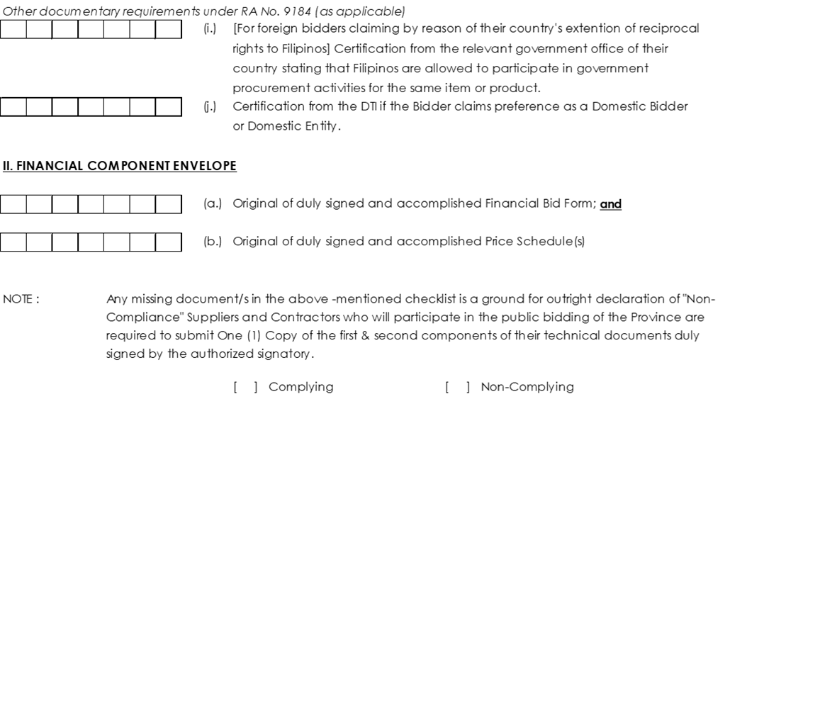

**SECTION ix.**

**Other bidding documents**



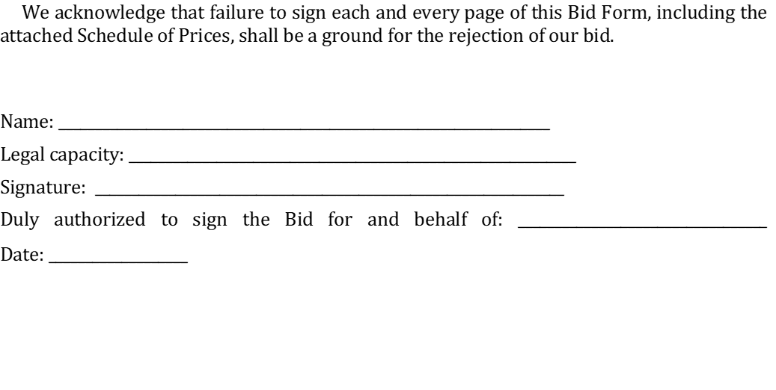

















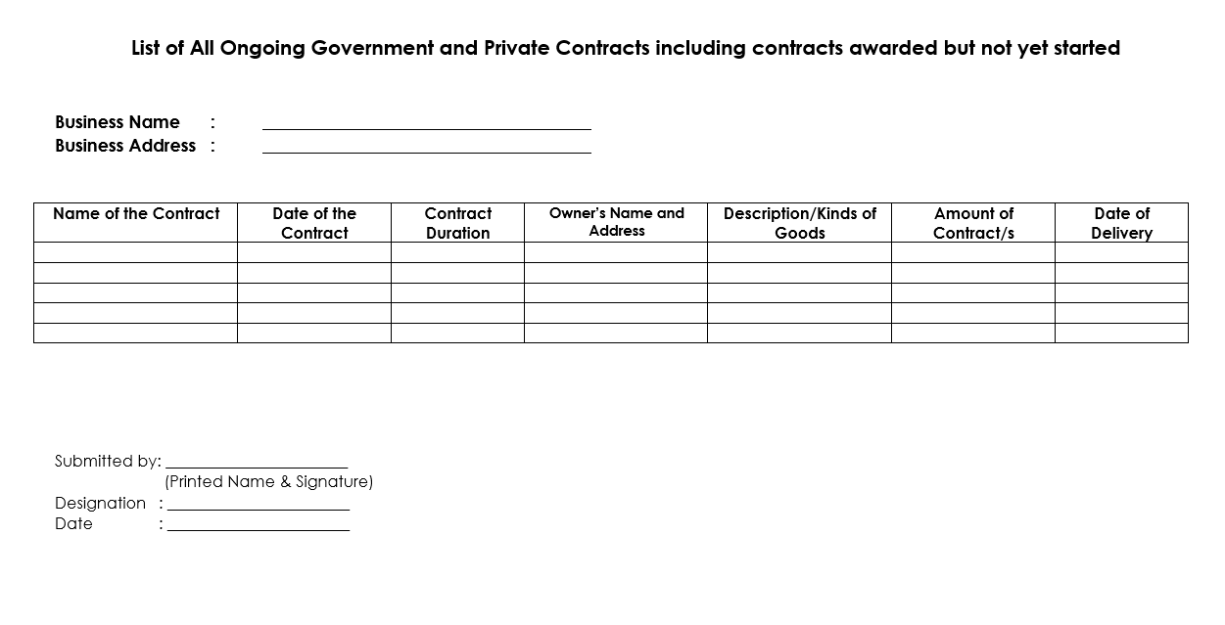

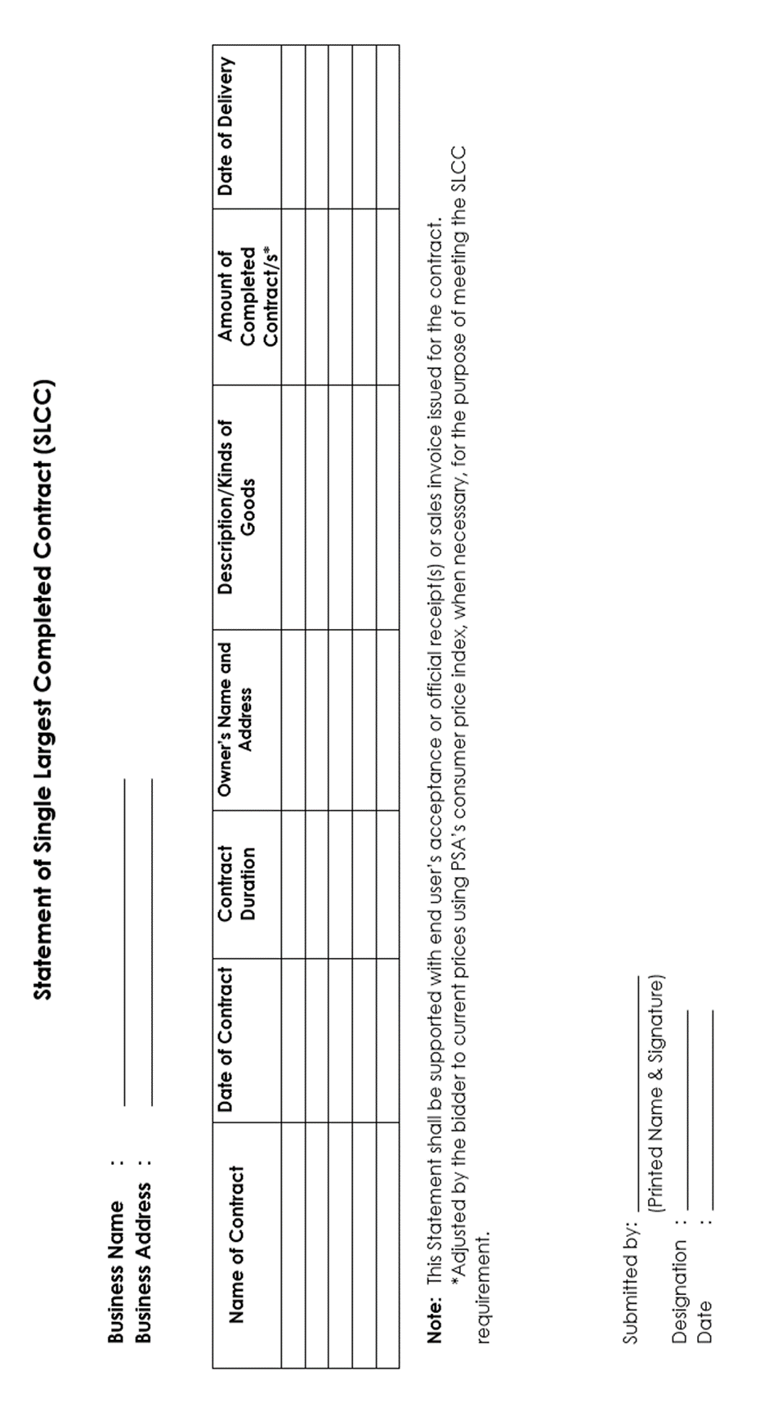

**NFCC COMPUTATION FOR ELIGIBILITY CHECK (REVISED)**

1. Summary of the Applicant Supplier’s/Distributor’s/Manufacturer’s assets and liabilities on the basis of the attached income tax return and audited financial statement, stamped “RECEIVED” by the Bureau of Internal Revenue or its duly accredited and authorized institution, for the preceding calendar/tax year which should not be earlier than two (2) years from the date of submission.

|  |  |  |
| --- | --- | --- |
|  |  | Year 20 |
| 1. | Current Assets |  |
| 2. | Current Liabilities |  |
| 3. | Net Working Capital |  |
| 4. | Total value of all outstanding or ongoing Projects |  |

1. The Net Financial Contracting Capacity (NFCC) based on the above data is computed as follows:

**NFCC= [(Current assets minus current liabilities) (15)] minus the value of all outstanding or uncompleted portions of the projects under ongoing contracts, including awarded contracts yet to be started, coinciding with the contract to be bid.**

NFCC=P

Submitted by:

Name of Supplier/Distributor/Manufacturer

Signature of Authorized Representative

Date:

1. In the case of Framework Agreement, the undertaking shall refer to entering into contract with the Procuring Entity and furnishing of the performance security or the performance securing declaration within ten (10) calendar days from receipt of Notice to Execute Framework Agreement.